**Coal lab 04**

Name: Syed Muzzamil Waseem

SID: 11067

Question 1

CODE:

INCLUDE Irvine32.inc

.data

;Syed Muzzamil Waseem 11067

val1 dword 10

val2 dword 20

.code

main PROC

mov eax,val1

call writeint

call crlf

jg label1

label1:

inc eax

call writeint

call crlf

cmp eax,val2

jl label1

exit

main endp

end main

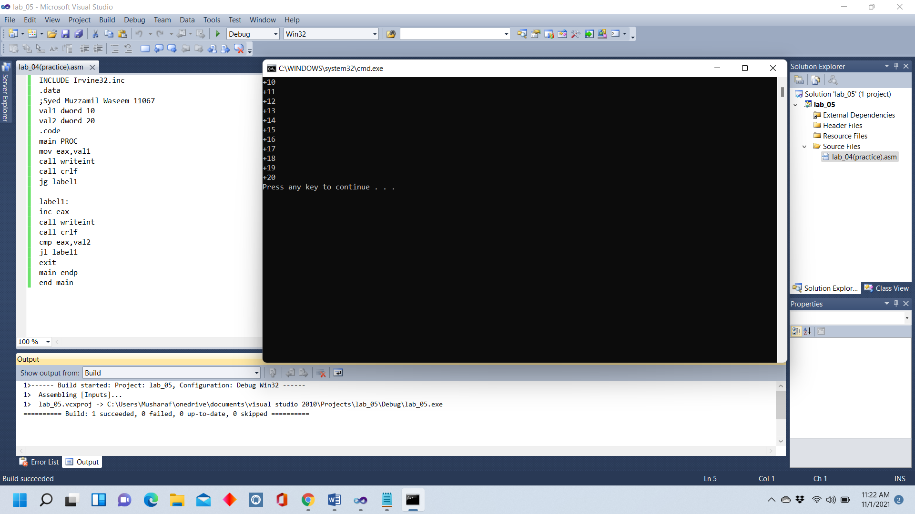

Question 2

CODE:

INCLUDE Irvine32.inc

.data

;Syed Muzzamil Waseem 11067

num1 dword 47

num2 dword 22

num3 dword 31

print byte "The highest number is"

.code

main proc

mov eax,num1

mov ebx,num2

mov ecx,num3

label1:

cmp eax,ebx

call writeint

call crlf

label2:

cmp ebx,ecx

call writeint

call crlf

label3:

cmp ecx,eax

call writeint

call crlf

exit

main endp

end main

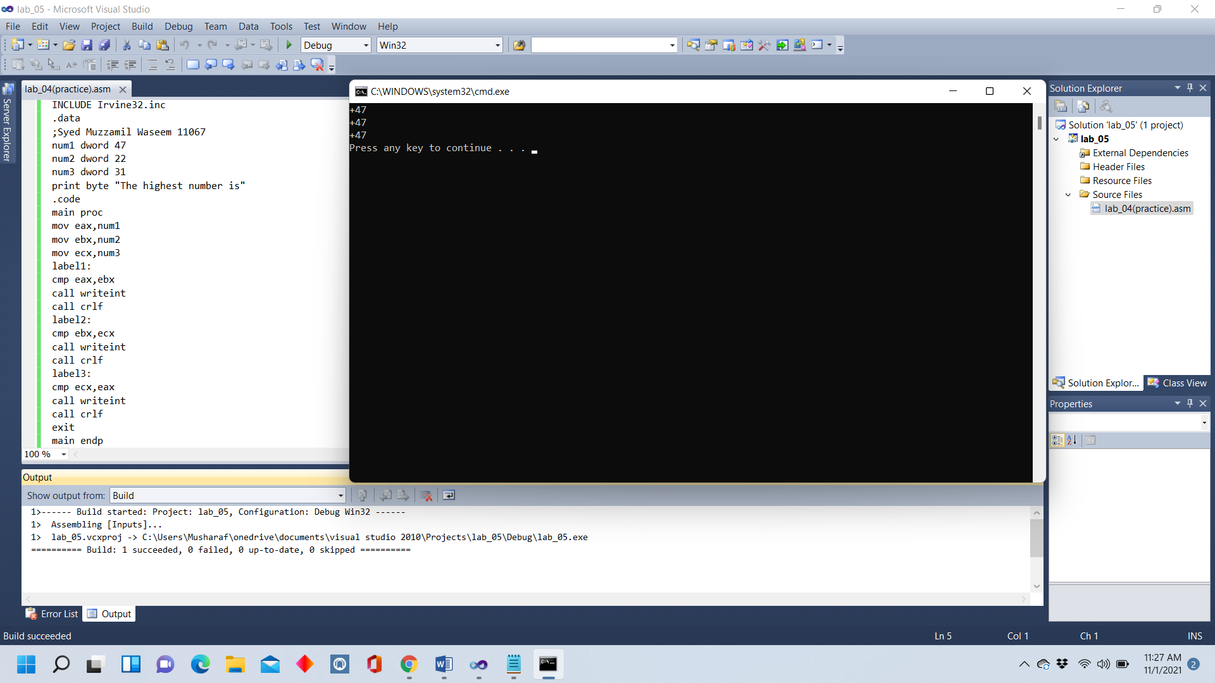

Question 3

CODE:

INCLUDE Irvine32.inc

.data

;Syed Muzzamil Waseem 11067

.code

main PROC

mov eax,20

call writeint

call crlf

jg label1

label1:

dec eax

call writeint

call crlf

cmp eax,1

jne label1

exit

main ENDP

END main

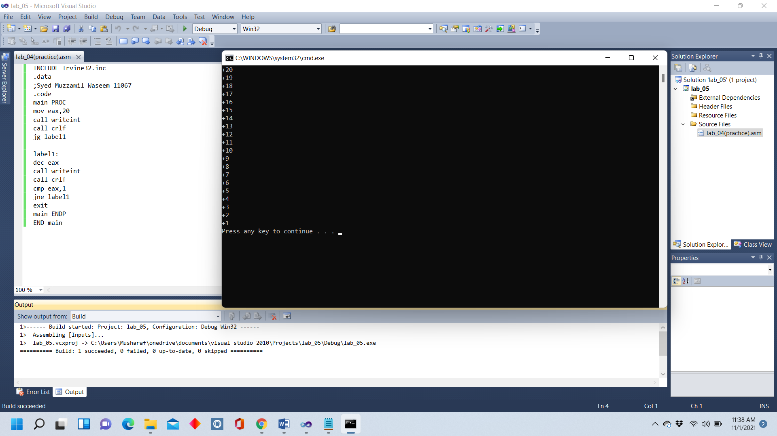

Question 4

CODE:

INCLUDE Irvine32.inc

.data

;Syed Muzzamil Waseem 11067

.code

main PROC

mov eax,0

mov ecx,4

L1:

inc eax

mov edx,eax

cmp eax,3

JE L2

call writeint

call crlf

loop L1

L2:

mov eax,0

add edx,1

mov eax,edx

call writeint

call crlf

loop L2

exit

main ENDP

ENd main

